INTRODUCTION

“Draft revision of the Law on Minerals”

August 01, 2023 | Ulaanbaatar city

- Preamble section.
The revised draft of the Law on Minerals has been developed in accordance with the Constitution of Mongolia and other laws.
Section 4 of Article Five of the Constitution of Mongolia states that “The state shall regulate the economy to achieve the goals of ensuring national economic security and the social development of all private enterprises and the population,” and, in Article 6, Part 1, it is established that “the land, its subsoil, forests, water, animals, plants, and other natural resources in Mongolia are under the sole jurisdiction of the people and the protection of the state”, while, in Part 2 of Article 6, it is stipulated that, “with respect to lands not owned by citizens of Mongolia, the subsoil, its resources, forests, water resources, and wildlife are considered public property of the state”.
Article 131 of the Resolution of the State Great Khural on “Approving the main priorities for improving the legislation of Mongolia until 2024” states that the draft law on amendments to the Law on "Minerals" shall be developed in 2021, as well as in the minutes of the 14th Cabinet meeting in 2021, "In connection with the approval of the revision of the Law on the Administration, Units and their Management of Mongolia, the Government was assigned to draft relevant laws to harmonize other laws and regulations with the Law and submit them to the State Great Khural.
In Section 3.2.6 of the “2020-2024 Action Program of the Government of Mongolia,” it is stated that mining institutions will be strengthened, responsible mining will be developed, licensing will be made open to the public, and permits issued in violation of the law will be revoked; Section 3.2 of the action plan for the implementation of the program further articulates that by developing transparent and responsible mining and value-added production, by enriching mineral resources, the goal is to create a stable and multi-pillar economic structure and implement the principle of fair distribution of resources.
- The emerging situation.
In 2006, the Law on Minerals was revised, comprising 11 chapters and 66 articles. During the law's implementation period, 16 amendments have affected a total of 11 chapters, 59 articles, and provisions of the law.
Specifically, 5 articles, 95 sections, and 101 clauses were amended; 48 sections and 54 clauses were newly added; 22 sections and 28 clauses were restructured; 10 articles and 3 clauses were deemed invalid; otherwise total more than 299 amendments were made to enhance legal regulation, but despite these modifications, the law has deviated from its originally approved concept, resulting in a loss of its intended content and purpose.
Additionally, by Order No. A/67 of 2017 from the Minister of Justice and Internal Affairs, a Working Group was established with the task of eliminating duplication and violations of laws and regulations in the mining sector. The working group analyzed 10 laws such as “Law on Minerals”, “Law on Petroleum”, “Law on Subsoil”, “Law on Petroleum Products”, “Law on the prohibition of mineral exploration and use in protected areas and forest areas with the source of the rivers, water reservoirs” “Law on the Prohibition of Searching for and Using Minerals in Areas of Watersheds and Forests”, “Law on the procedure for compliance with the law on the prohibition of mineral exploration and use in protected areas and forest areas with the source of the rivers, water reservoirs”, “Law on Nuclear energy”, Law on the procedure for compliance with the law on nuclear energy”, “Law on widely distributed minerals”, “Law on monitoring the circulation of explosives and explosives” currently in force in the mineral resources sector and identified a total of 267 duplications and 150 violations, necessitating the need to eliminate these issues within the aforementioned laws. Figure 1 shows the changes, duplications and actions in the Law on Minerals.
Figure 1.
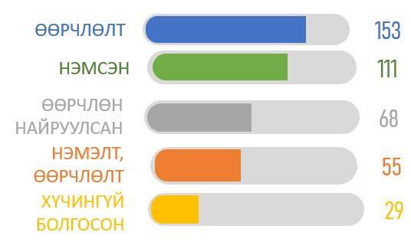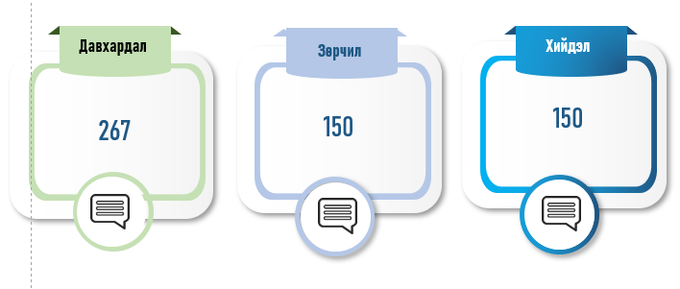
Although there was a regulation to issue special licenses for mineral exploration through application, selection, and virtually, in the past, special licenses were issued for a period of 5 years from 2010 to 2015, for a period of 1 year from the end of 2019, and during the 16 years of implementation of the Law on Minerals approved in 2006, the process was halted for a total of 6 years. The current law does not fully regulate the issuance of exploration licenses, which creates uncertainty for investors, stalls exploration, and reduces investment in the sector. The stagnation of exploration activities is directly attributed to the instability of the legal environment. Granting special exploration licenses solely through the selection process may jeopardize the future resource availability of the mining and processing sector. Hence, a legal regulation that combines the application and selection methods with specific criteria for exploration license applicants is required.
The number of exploration licenses and the amount of investment from 2006 are shown in the following figure.
Figure 2.
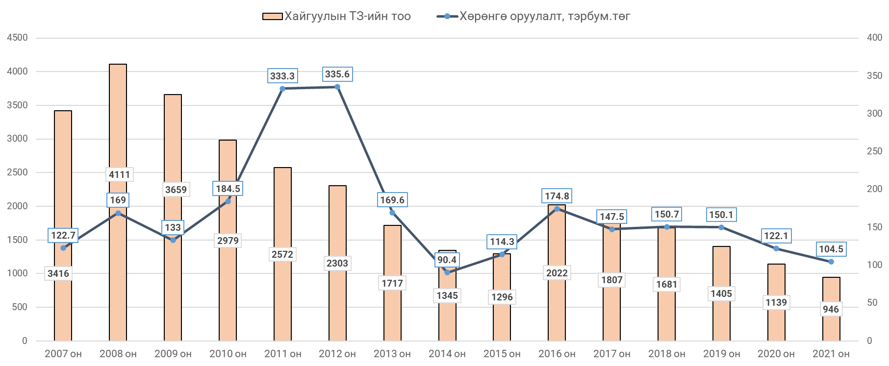
To enhance the impact on the economy, change negative social perceptions of mining, prevent the formation of abandoned mines in the future, and avoid expanding the current unrehabilitated areas, it is imperative to implement effective and phased public policy measures, along with establishing rehabilitation and closure funds.
Mining activities are necessary to work in harmony with the earth and the environment, and if certain measures are not taken, there is a high risk of negative effects on the environment, large losses from natural disasters, heavy machinery, mechanisms and equipment that require sophisticated technology. There are many risks associated with the mining process, including landslides, floods, earthquakes, strong wind storms, electrical damage, fires caused by external influences and wildfires in open and underground mines, as well as damage to water ponds, mine buildings, mining equipment, storage, and transportation. As a result, life and health risks, public liability risks, management liability risks, and professional liability risks depend on the insurable risks of the mining industry. Therefore, there is a practical need to improve the legal framework that regulates the above-mentioned risks in the mining industry..
- Draft revision of the Law on Minerals.
Analyzing the above situation, there has been a notable shift in the state and substance of social relations governed by the 2006 Law on Minerals. Consequently, the law has undergone refinement based on provisions of Section 25.1 of Article 25 of the Law on Legislation, a draft for revising the Law on Minerals has been developed.
With this draft law, amendments to the Constitution of Mongolia are proposed, along with significant changes in Mongolia's social, economic, and legal relations. This includes the development of key economic sectors integral to Mongolia's development policy, aiming to create an export-oriented economy. Additionally, it seeks to establish a legal framework for geological research and mining, including the approval of technical and economic justifications, addressing their legal consequences, mineral exploration, extraction, beneficiation, processing, sales, environmental protection, labor safety, mine exploitation, and the management of related issues during the closure stage.
In addition to the above, the following issues have been arranged to be included in the draft law:
- Mineral enrichment activities;
- Conducting mineral exploration activities with private funds;
- Prohibition of mineral exploration, use, enrichment, and the place of operation under a special regime
- Local relationships and community engagement in the industry
- The closure of mines and factories is reflected in new regulations.

The draft revision will have 18 chapters and 76 articles and will have the following structure.
Chapter One (General basis): the purpose of the law, legislation related to minerals, the scope of the law, definitions of important terms, and the principles governing mineral exploration, exploration, utilization, and enrichment, ownership, the various types of special permits, regulations surrounding mineral exploration and usage, designated areas where enrichment is prohibited, locations operating under special regimes, and the general requirements imposed on special license holders, the geological and mining industry, providing a comprehensive framework for these activities.
Chapter Two (Geological research and prospecting activities): Relations with Geological Surveys, Prospecting Activities, and Regulatory Requirements for Prospecting Activities;
Chapter Three (Exploratory Activities): requirements for exploration license areas, exploration license issuance, exploration license fees, rights and obligations of exploration license holders, regulations related to exploration license expiration, revocation, cancellation, and exploration activities;
Chapter Four (Operational activities): Requirements for the area of a special license for use, granting a special license for use, payment for a special license for use, the rights and obligations of the holder of a special license for use, expiration or cancellation of a special license for use, operations to prepare the deposit for use, carrying out exploitation activities, and exploration activities during exploitation regulations regarding;
Chapter Five (Enrichment Activities): Regulations such as the issuance of a special concentration license, the rights and obligations of the holder of a special concentration license, the termination and cancellation of a special concentration license, the requirements for conducting concentration activities, waste farming, and circulating water supply;
Chapter Six (Transfer and pledge of licenses): Regulations relating to the transfer and forfeiture of licenses;
Chapter Seven (Mine and plant closing operations): Regulation of closure activities, their types, planning, financing of closure activities, implementation of closure activities, reporting, post-closure monitoring, maintenance, and monitoring;
Chapter Eight (Control system for minerals quality): Regulations of control system of minerals quality
Chapter Nine (Report on results of exploration work, feasibility study, design work,): Requirements for developing report on results of exploration work, feasibility study, design work;
Chapter Ten (Royalties): Regulations of royalties, royalties concering strategically important deposits;
Chapter Eleven (Environment protection): Regulations of protecting environment in the course of geological survey, prospecting, exlporation, exploitation, and processing.
Chapter Twelve (Local communication): Regulations of local communication, local engagement during the geological survey to be conducted with state budget, prospecting, exploration, exploitation, and processing;
Chapter Thirteen (occupational safety and health, technological audit) Regulations of general requirements for occupational safety and health issues, and technological audit;
Chapter Fourteen (Report): Regulations of planning and report, report on geological survey and prospecting, action plan for exploration, exploitation and processing, royalities report;
Chapter Fifteen (state regulation on the geology and mining sector) Regulations of the power of Parliament and Government, the rights and duties of the central state administrative organization in charge of geology and mining, the functions of the state administrative organization, the power of Citizen’s representative council, the power of governers of province, capital city, soums and districts, local units in charge of geology and mining, Mining investment promotion council, the Minerals professional council, Mining survey and development center;
Chapter Sixteen (Geology and mining database): Regulations of forms, types and structure of the database of geology and mining sector, activities in maintaining and forming of the database;
Chapter Seventeen (Financial records and reimbursement): Regulations of financial records in the mining, and reimbursement of the cost of geological and exploration work conducted with the state fund;
Chapter Eighteen (Liabilities, others): Reflects the liabilities of law breakers and the effective date of the law.
- Expected outcome with the approval of the law.
With the approval of the revised draft of the law on Minerals, legal regulations will be created covering all issues including geological survey, prospecting, exploration, exploitation and beneficiation, sales, environment protection, rehabiliation, mining closure, occupational safety, risk managment of mining, local coordination; it includes:
Developing a transparent and accountable mining in accordance with international trend, it will make public confidence in the mining sector development increase, and local resistance decrease. Thus, a smooth implementation of mining projects will be carried out;
An appropriate use of subsoil resources by industrial methods, environment protection, increase export and returns to the society and economy, equal access to natural resources for every citizen, regulation of relations between the government and non government organizations, private sectors, local communities and citizens;
The role, cooperation and control system of state and local administrative organizations, license holders and enterprises will be clarified;
With a flexibel tax environment, foreign investment will be improved while making the distribution of revenues to the state and local budget more rational and transparent;
Mining operations at all stages from exploration to planning and closure will be carried out transparent, open, controlled and accountable while public participation is ensured based on international best practices;
By implementing a new mine closure system alongside a financial guarantee mechanism, the risk of abandoned and unrehabilitated mining sites will be significantly reduced.
The regulation of mineral-related terms as prescribed by law will become clearer and more understandable, enhancing coordination between laws and eliminating duplication, overlaps, and contradictions.
By amending, revoking, and repealing relevant laws is believed to eliminate duplication and contradictions while resolving legal challenges and regulatory ambiguities once and for all.
- Drafting new legislation, amendment, repealing legislation.
The draft law complies with the requirements of the Law on Legislation and aligns with the Constitution of Mongolia, international treaties and conventions, and other national laws.
In connection with this draft law, a series of related legislative initiatives will be undertaken. These include drafting a law on amendments to various existing laws, such as The Law on Repeal of the Law on Minerals, the Law on Repeal of the Law on Commonly Distributed Minerals, the Repeal of the Law on the Prohibition of Exploration and Use of Minerals in Protected Areas and Forest Reserves Accounting Act, Corporate Income Tax Act, Labor Migration Act, Minerals Act Compliance Act, Environmental Protection Act, Construction Act, Environmental Impact Assessment Act, Petroleum Law, Law on Land, Law on Subsoil, Law on Prevention of Increase in Prices and Shortages of Certain Major Goods and Products, Law on Reducing Negative Impacts, Law on Support of Small and Medium Enterprises and Services, Law on Permits, Law on Violations, Future Law on Heritage Funds, Law on Cadastral Mapping and Land Cadastre, Law on Land Ownership to Mongolian Citizens, Law on Administration and Territorial Units of Mongolia, Law on Value Added Tax, Law on Forestry, Law on Cultural Heritage Protection , General Tax Law, Law on Specially Protected Environmental Zones, Law on Specially Protected Areas, Law on Budget, Law on State Stamp Fees, Law on Water, Law on Nuclear Energy, Law on Pledge of Movable Property and Intangible Assets, Investment Law specialized banking law, Criminal law and other relevant laws.
---oOo---

